If using BRMS, run the following commands on each LPAR and send the save file. The save file can be zipped to transfer easier

CRTDTAARA DTAARA(QTEMP/Q1ARPTRETN) TYPE(*CHAR)
PRTRPTBRM TYPE(*CTLGRPSTAT)
and send in the spooled file in text (.txt) format. (files need to be downloaded as .txt files and not as pdf and converted)
IMPORTANT: Both these commands need to run in the same job stream

If you have multiple systems in a BRMS network, you can use the following command on one of the systems to run the reports for the other systems

CRTDTAARA DTAARA(QTEMP/Q1ARPTRETN) TYPE(*CHAR)
PRTRPTBRM TYPE(*CTLGRPSTAT) FROMSYS(xxxxxxxxx)
and send in the spooled files in text (.txt) format. (files need to be downloaded as .txt files and not as pdf and converted)
IMPORTANT: Both these commands need to run in the same job stream

To download the reports as .txt files, follow one of the two methods shown on the pages below:

- i Access Client Solutions method:
Open the i Access Client Solutions application and select the LPAR (System) from which the reports are to be downloaded.

Select “Printer Output” and log in.
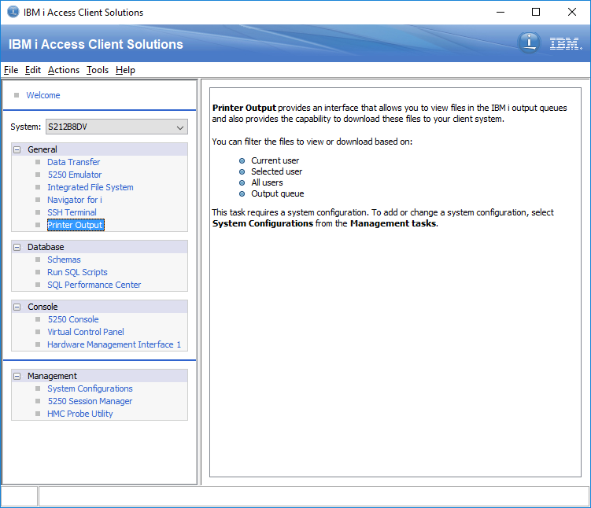

Change Filter sections, if necessary, to locate the *SPLFs with the BRMS data.
Select the file or files to download, and then click Actions->Download… to get the following dialogue.

Be sure to de-select TURN OFF THE “USE PDF FORMAT IF AVAILABLE” option, then click OK.

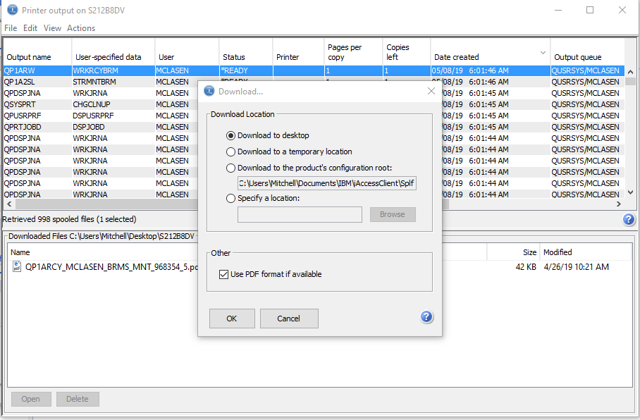

Method 2: Using the Navigator for i
- Open the Navigator (from the same software above or directly via IP).
- Select “Basic Operations->Printer Output”
- Use the “Actions->Include…” option to change the list contents (user, etc) if necessary.
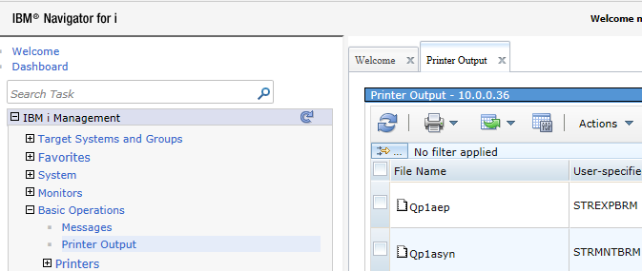
- Select the files to download from the list on the right by clicking the checkbox next to each desired file.
- Select Actions->Export As… and select the ASCII text option.
- Click OK on the Confirmation Screen.
- Use the SAVE option that windows displays to save the files locally.

